<!DOCTYPE HTML PUBLIC "-//W3C//DTD HTML 4.0 Transitional//EN"><!-- Created from PDF via Acrobat SaveAsXML --><!-- Mapping table version: 28-February-2003 --><DIV class=Sect>

Configuration-Specials, Diagonals and Cutouts

Diagonal Cuts
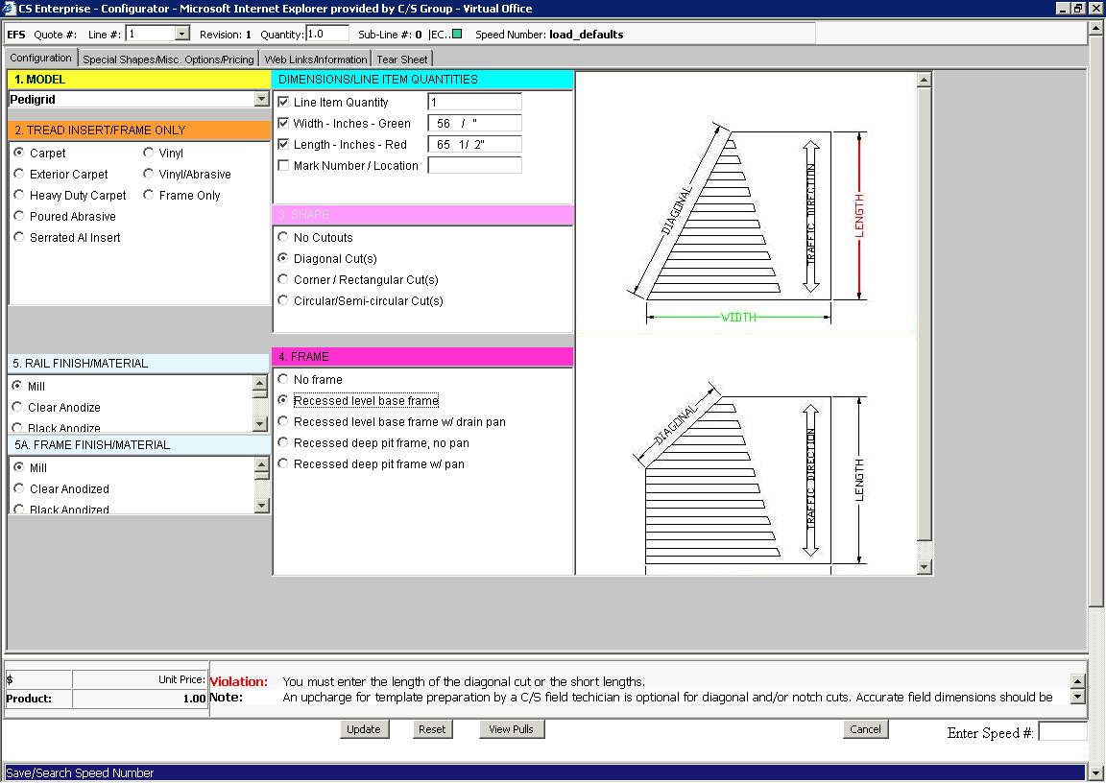
• Select a model, for our example “Pedigrid.”
• Select the tread insert.
• Select “Diagonal Cuts.”
• To complete the configuration, click on the “Special Shapes/Misc. Options/Pricing” tab.
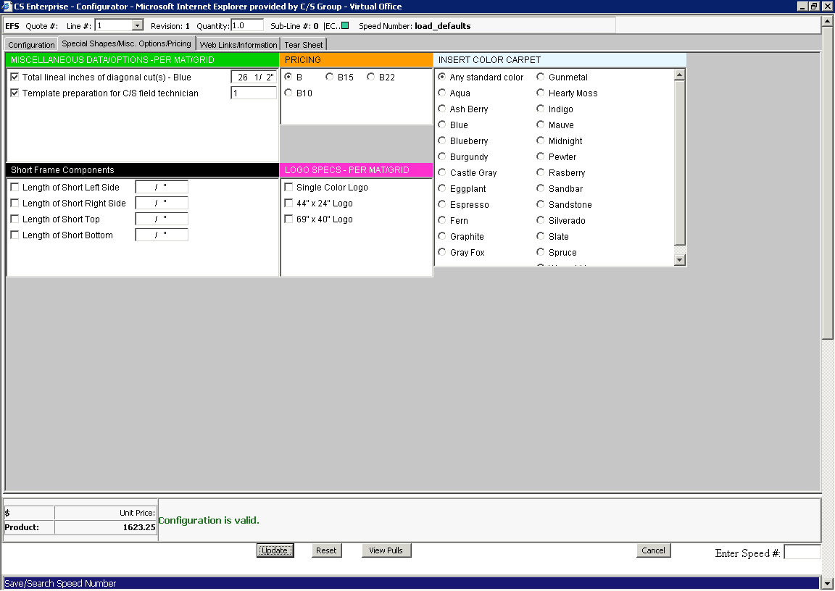
• In the green “Miscellaneous Data/Options” block enter the total length of the diagonal cut in inches.
• Select Template if required. Enter the number of templates required.

Circular Semi-Circular Cut(s)
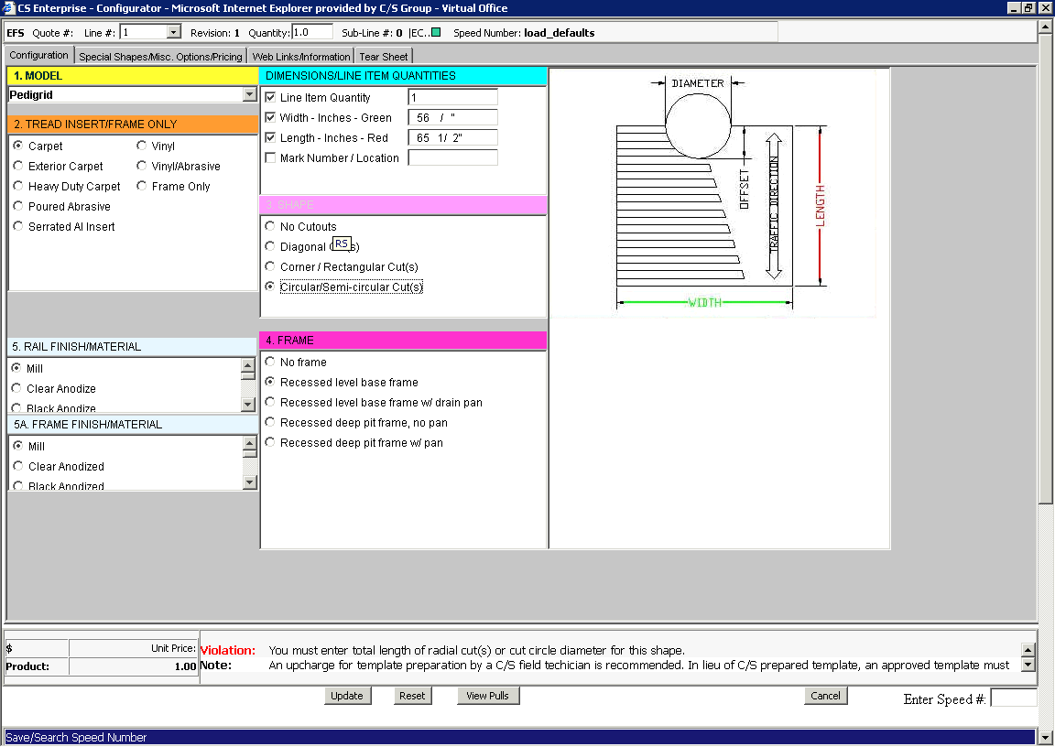
• Select a model, for our example “Pedigrid.”
• Select the tread insert.
• Select the “Circular Semi-circular Cut(s)” from the shape block.
• To complete the configuration click on the “Special Shapes/Misc. Options/Pricing” tab.
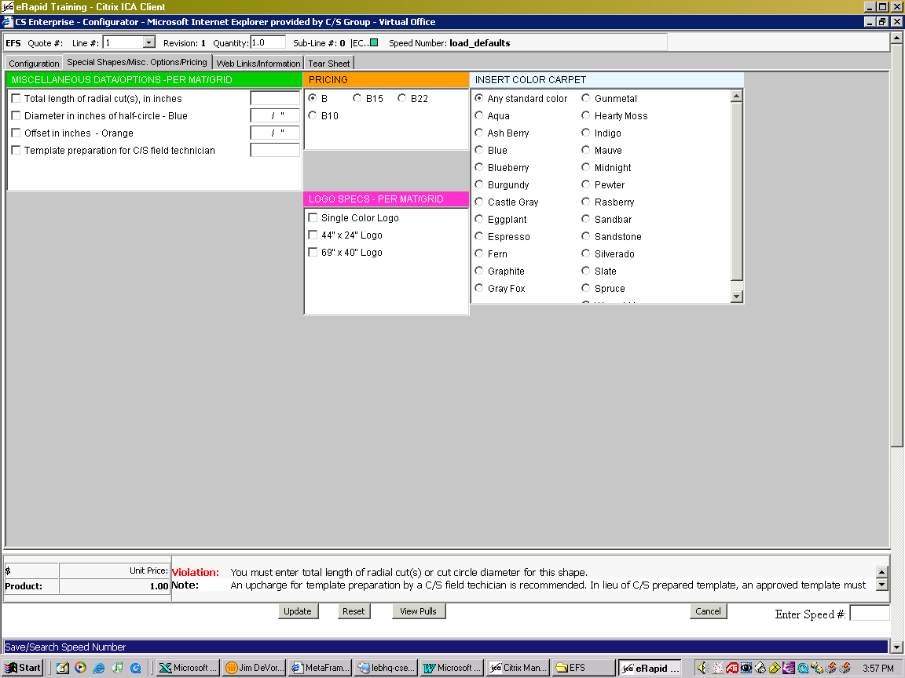
• Select one of the following in the green “Miscellaneous Data/Options” block:
• Total length of radial cut(s), in inches
Or
• Diameter in inches of half-circle
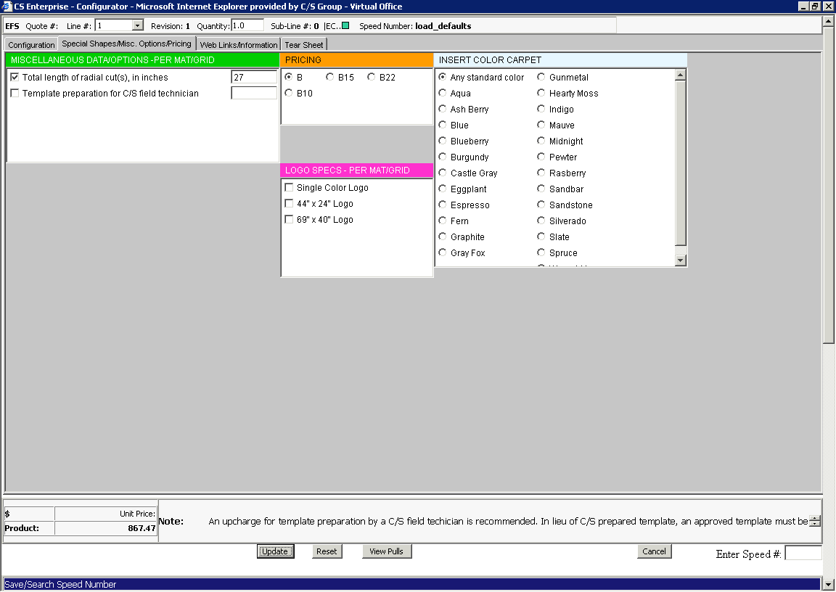
For total length of radial cuts:
• Enter the length of cut(s) in inches in the Miscellaneous/Data Options” box as shown above (27).
• Tab to exit out of the field.
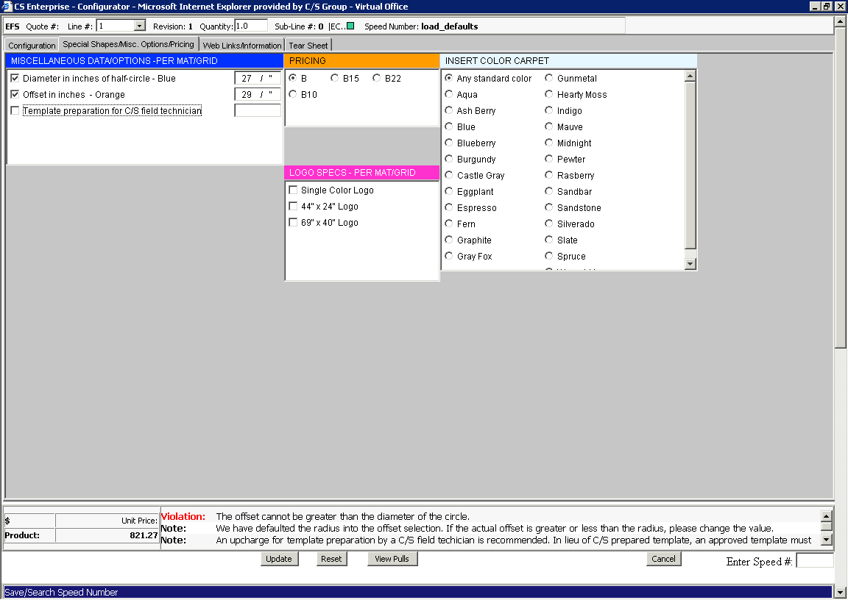
For the diameter and offset:
• Enter the inches and fraction in the “Diameter in inches of half circle” box (in the example above we use 27”).
• The offset defaults to the radius or half of the diameter. To change the offset click in the dimension box and enter inches and any fraction.
• Select template if required.

Corner / Rectangular Cut(s)
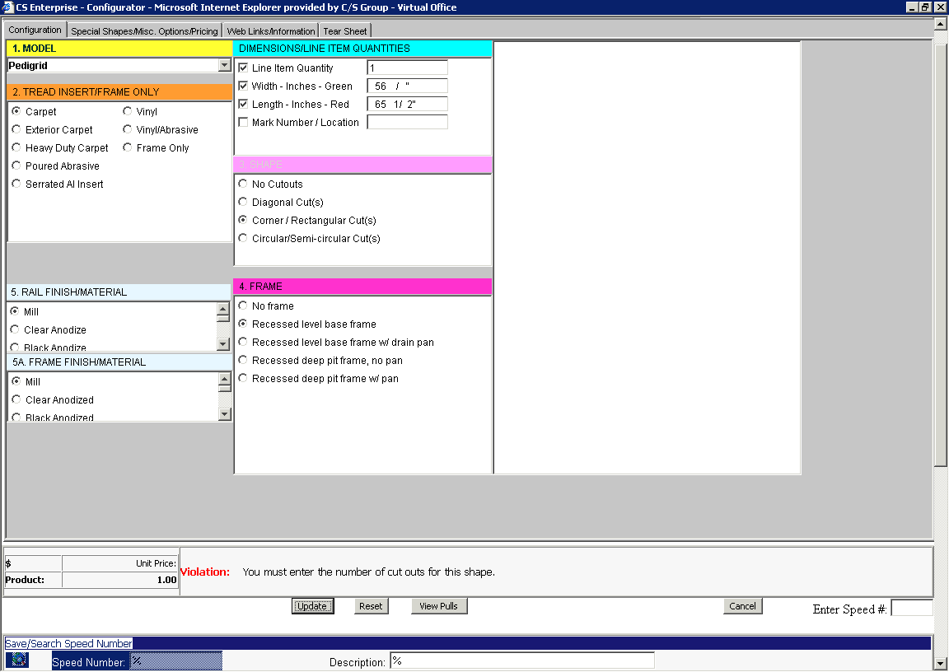
• Select a model, for our example “Pedigrid.”
• Select the tread insert.
• Select the “Corner / Rectangular Cut(s)” from the shape block.
• To complete the configuration click on the “Special Shapes/Misc. Options/Pricing” tab.
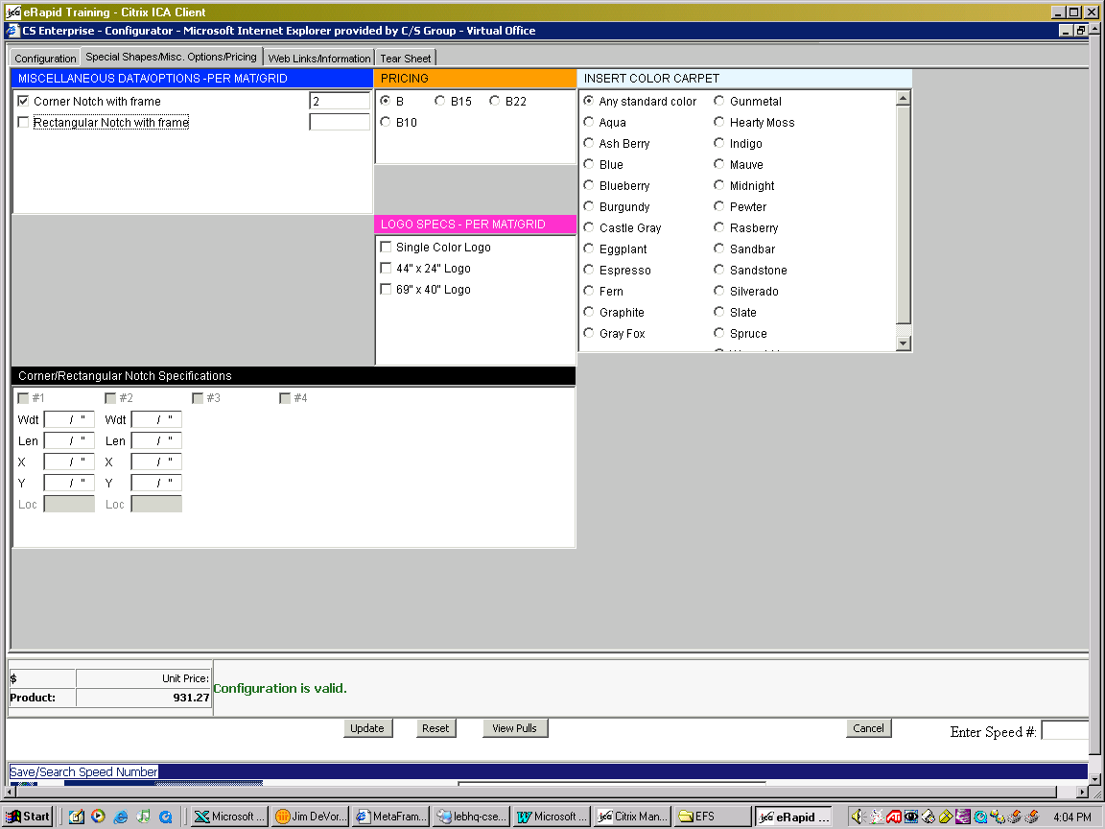
• Select one of the “Notch” options.

End Section.
</DIV>

